Practical 8: Binary Tree Traversals and Binary Search Tree Insertion
Practical Aim
To implement binary tree traversals and binary search tree insertion, and develop the ability to reason about how the order of visiting nodes changes the information retrieved from a tree.
Problem 1
A company stores its organizational hierarchy as a tree — the CEO at the top, managers below, and employees at the leaves. Different departments need the hierarchy printed in different orders: HR wants each manager printed between their left and right sub-teams, the archive department wants each manager printed before their sub-teams, the payroll department wants each manager printed after all their sub-teams are listed, and the floor manager wants everyone printed level by level from top to bottom. Given a binary tree representing the hierarchy, implement all four printing orders and display the result of each.
Describe how your solution for level-by-level printing differs from the other three. What additional structure did you need to use, and why does the same recursive approach that works for the other three not directly apply here?
SOLUTION:
https://github.com/prathameshpandir-dev/DSA-Batch-B-SHP/tree/main/practical-8
OUTPUT:
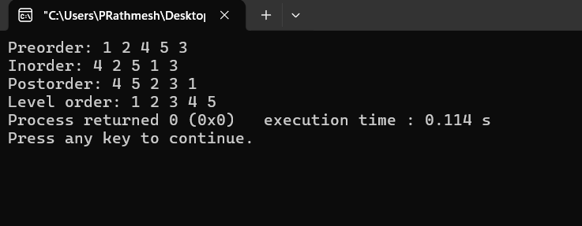

PROBLEM FACED:
The main difficulty was understanding the order in which nodes are visited in each traversal. Level order also needs a queue, unlike inorder, preorder, and postorder which can be implemented recursively.
CONCLUSION:
All four binary tree traversals were successfully implemented. Inorder, preorder, and postorder use recursive traversal, while level order uses a queue to process nodes level by level.
Problem 2
A school library uses a system where every book is assigned a unique code when it arrives. Books are organized so that at any shelf position, all books to the left have smaller codes and all books to the right have larger codes. This arrangement lets staff find any book quickly by always knowing which direction to look. Given a sequence of book codes arriving one by one, insert each into the correct position and print the inorder sequence after all insertions are complete.
Describe how your solution decides where to place each new book code. What property of the final inorder sequence tells you whether all insertions were performed correctly?
SOLUTION:
https://github.com/prathameshpandir-dev/DSA-Batch-B-SHP/tree/main/practical-8
OUTPUT:

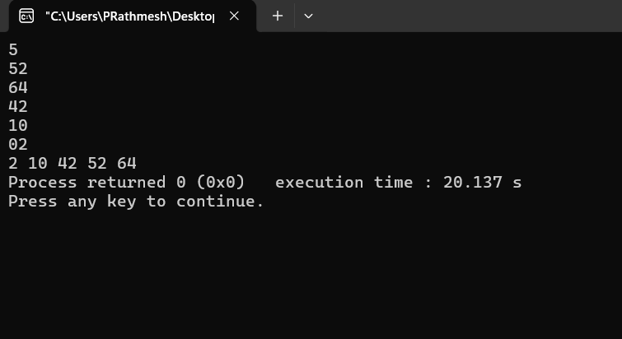

PROBLEM FACED:
The main difficulty was comparing each new code with the current node and repeatedly moving left or right until the correct empty position was found.
CONCLUSION:
The BST insertion was successfully implemented. The final inorder traversal produces the book codes in sorted order, which confirms that the BST property was maintained.
Key questions
1. Problem 1
Answer: No. Preorder output alone does not normally give enough information to reconstruct the original binary tree because different tree structures can have the same preorder sequence. Additional information such as inorder traversal is needed.
2. Problem 2
Answer: If inorder output is not sorted, there may be an error in BST insertion, inorder traversal, or both. The insertion can be checked separately by examining the left-smaller and right-larger rule, while traversal can be tested on a known tree.
Overall Conclusion
The practical successfully implemented four binary tree traversals and BST insertion. The role of recursion, queues, and the sorted property of inorder traversal in a BST was understood.

